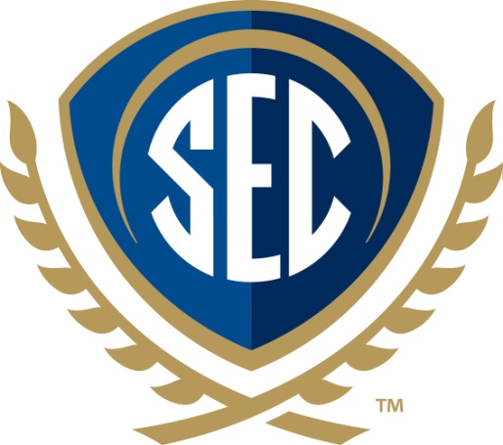

SEC Academic Conference News Brief (Words: 155)

The 2017 SEC Academic Conference will be held March 27-28 in Starkville, Mississippi, at The Mill Conference Center at Mississippi State University. Entitled “The Future of Water: Regional Collaboration on Shared Climate, Coastlines, and Watersheds,” this event will showcase contributions from researchers at SEC universities and from around the region.

Keynote speakers include John M. Barry, author of the book “Rising Tide: The Great Mississippi Flood of 1927 and How It Changed America,” Dennis Dimick, former executive environment editor at National Geographic, and Jay Famiglietti, the senior water scientist at the NASA Jet Propulsion Laboratory at the California Institute of Technology.

The SEC Academic Conference will feature presentations from representatives from all 14 SEC universities, panel discussions, breakout sessions, and a competition where SEC students were challenged to design interdisciplinary solutions to enhance sustainable water resources.

The SEC supports collaborative higher education programs and activities involving administrators, faculty and students through its SECU academic initiative.

