Analytics Grant Expense Summary Report
- Log into MyOleMiss
- Go to the Employee Section
- Go to the Analytics section box
- Select the GM Departmental tab
- Select the gray square next to the desired report to highlight the row and open by selecting the Launch Report icon

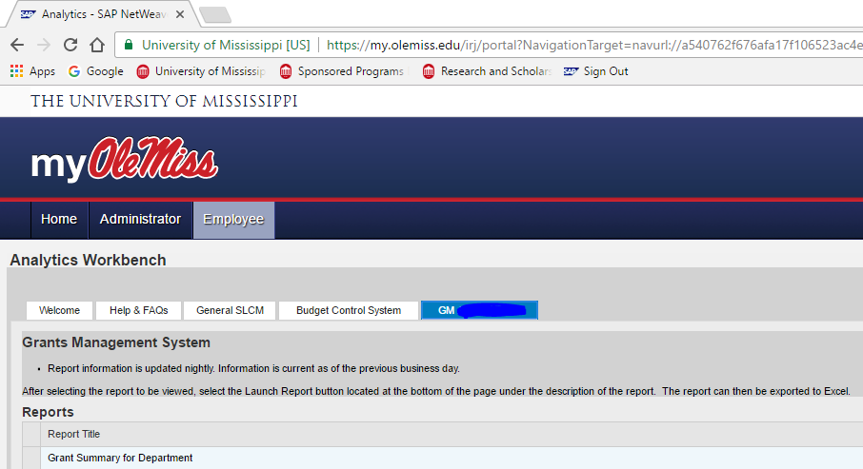

- After selecting the Launch Report icon, a new window will open (be sure your browser allows pop-ups)
- Enter selection criteria in the Input Screen (Grant for entire award or Internal Order for selected portion of award) and select Submit.
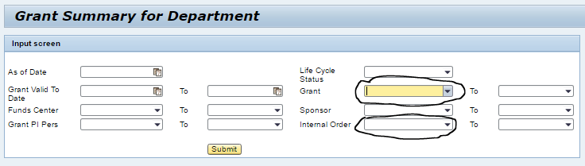

- For detailed information, click to highlight a selected row and select the respective details icon (Expense, Commitment, Current Budget) which will open an additional screen at the bottom showing line item details.

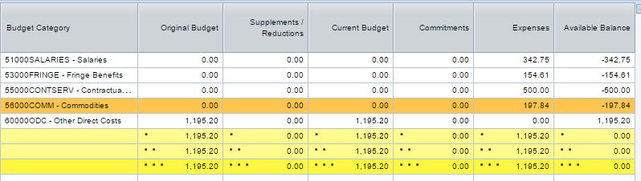

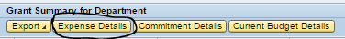

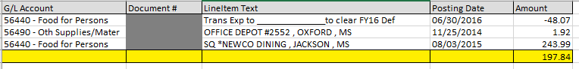

NOTES:
- You may choose to copy Analytic reports via the clipboard or download via excel
- MyOleMiss reports are updated nightly and will not reflect the current day’s activity until the following day
- You may sort and subtotal the Grants Summary for Department report by using the drop-down menu in the Input Screen
- The Payroll Details Report is displayed at the individual employee level

